

**KULLIYAH OF INFORMATION AND COMMUNICATION TECHNOLOGY**

**CSC 3102 DATA STRUCTURES AND ALGORITHM II**

**SEMESTER 2, 2018/2019**

**SECTION 1**

**RESEARCH ON ROUND ROBIN ALGORITHM**

**PREPARED BY:**

|  |  |
| --- | --- |
| **NAME** | **MATRIC NO.** |
| Ahmad Zaidan Bin Adnan | 1718733 |
| Muhamad Salikin Bin Ismail | 1711083 |

**LECTURER**

DR. NURUL LIYANA BINTI MOHAMAD ZULKUFLI

**DUE**

14 MAY 2019

**Introduction**

Round-robin (RR) is one of the algorithms used in computing by process and network schedulers. Time slices (also referred to as time quanta) are assigned to each process in equal parts and circular order, handling all processes without priority (also referred to as cyclic executive) as the term is generally used. Round-robin scheduling is simple, easy to implement and resource starvation-free. Round-robin scheduling can also be applied to other scheduling issues, such as computer network data packet scheduling. It is a concept for the operating system.

**Explanation about Round Robin Algorithm**

A round-robin scheduler usually uses time-sharing to schedule processes fairly, giving each job a time slot or quantum (its CPU time allowance), and interrupting the job if it is not completed at that time. Next time a time slot is assigned to this process, the job is resumed. The scheduler selects the first process in the ready queue to execute if the process terminates or changes its state to waiting during its allocated time quantum. A process that produced large jobs would be favoured over other processes in the absence of time-sharing, or if the quanta were large relative to the sizes of the jobs. Round-robin algorithm is a pre-emptive algorithm as the scheduler forces the process out of the CPU after expiry of the time quota.

For instance, if the time slot is 100 milliseconds (ms) and job 1 takes a total of 250 ms to complete, the round-robin scheduler will suspend the job after 100 ms and give their time to other jobs on the CPU. Once the other jobs have had their equal share (100 ms each), job 1 will receive another CPU time allocation and repeat the cycle. This process goes on until the job is finished and on the CPU no longer needs time.

**Example**

Quantum time = 100 ms

|  |  |  |
| --- | --- | --- |
| **Process Name** | **Arrival Time** | **Execute Time** |
| P0 | 0 | 250 |
| P1 | 50 | 170 |
| P2 | 130 | 75 |
| P3 | 190 | 100 |
| P4 | 210 | 130 |
| P5 | 350 | 25 |

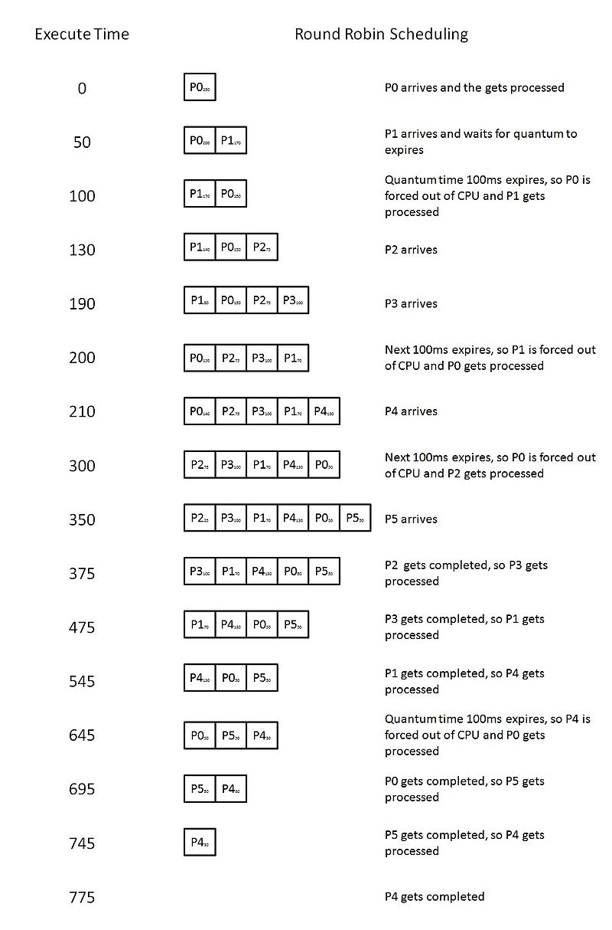

**Pseudocode**

**Input**

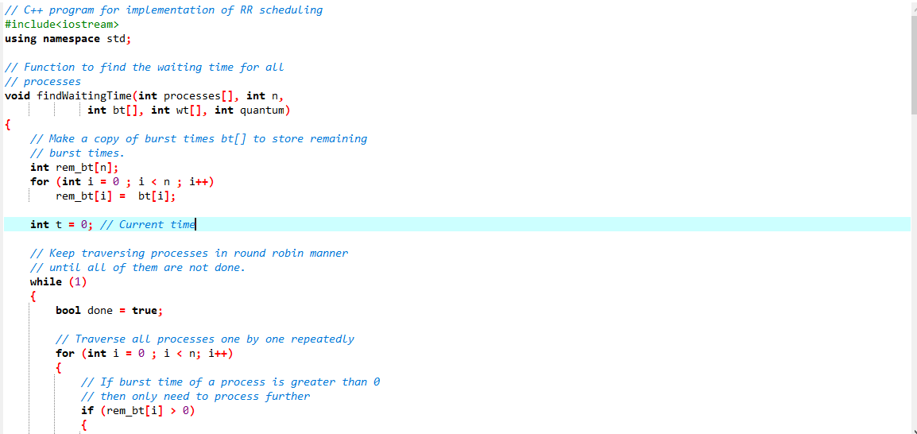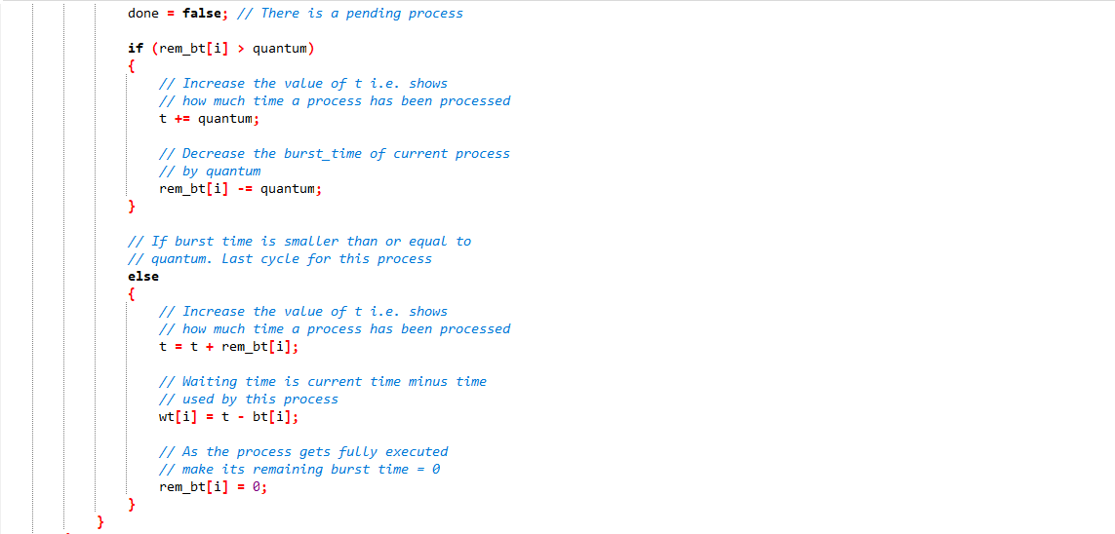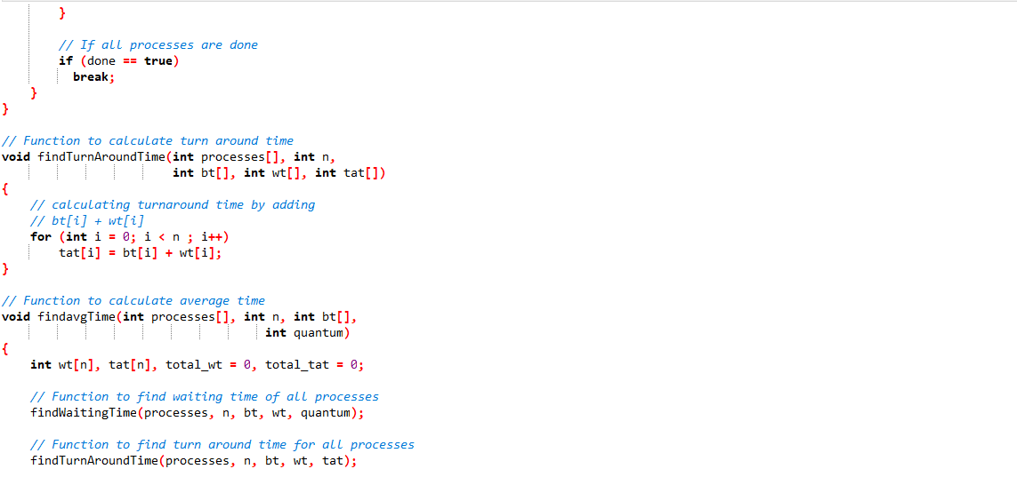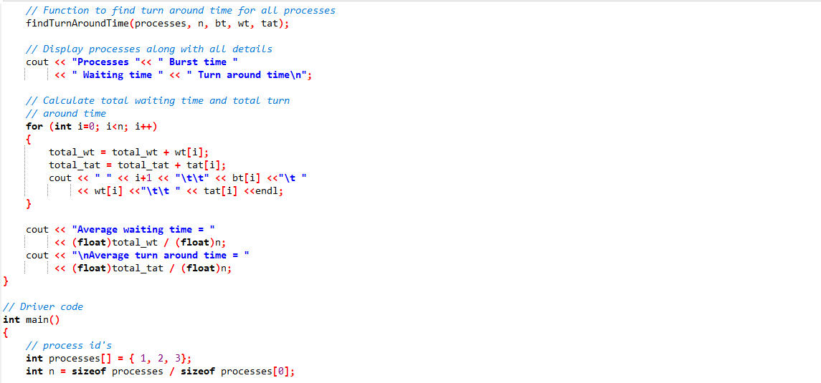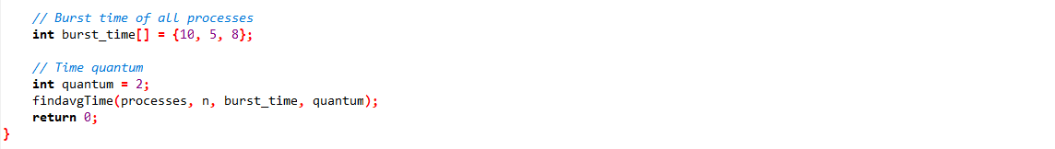

**Output**

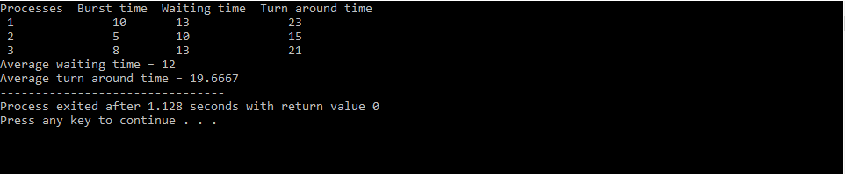

**Running Time**

O(n) because the running time of the algorithm grows in proportion to the size of input.

**Modification of Round-Robin Algorithm**

The disadvantage of round-robin algorithm is the time taken to complete the whole procedure. Therefore, a modification must be done to the algorithm to shorten the time taken by the algorithm. One method that can be done is changing the quantum of the algorithm. To change the quantum, first, the value in the quantum is determined by the average of the values in all procedures. By executing this method, the quantum limit cannot be too short. In addition, the arrival time of each procedure must be the same with other procedure.

**Examples**

|  |  |  |
| --- | --- | --- |
| **Procedure Name** | **Arrival Time** | **Execute Time** |
| P1 | 0 | 10 |
| P2 | 0 | 20 |
| P3 | 0 | 30 |
| P4 | 0 | 40 |
| P5 | 0 | 50 |

**Simple Round-Robin Algorithm**

Time quantum = 10 ms

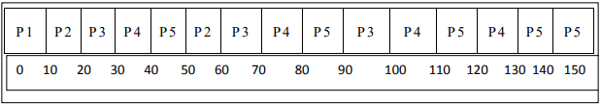

**Modified Round-Robin Algorithm**

Time quantum (average execute time) = 30 ms

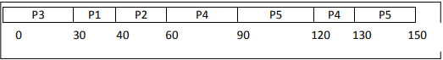

**Comparison between Simple and Modified Round-Robin Algorithm**

From both Gantt chart above, it can be identified that the modified round-robin algorithm finishes earlier than the simple round-robin algorithm due to the higher time quantum for the modified algorithm.

**Conclusion**

In conclusion, it is known that round-robin algorithm is crucial in computing systems especially operating systems. However, every algorithm can be improved to increase the efficiency of a system. One of the changes that can be made are by modifying the time quantum of a system.

**References**

* <https://www.tutorialspoint.com/operating_system/os_process_scheduling_algorithms.htm>
* <https://www.studytonight.com/operating-system/round-robin-scheduling>
* <https://www.javatpoint.com/os-round-robin-scheduling-algorithm>